DEPARTMENT OF CHEMISTRY AND ENVIRONMENTAL SCIENCE
SEMINAR SERIES
FALL 2024

WEDNESDAY, OCTOBER 30
TIERNAN HALL – LECT. HALL 1
1:00PM-2:20PM

GUEST SPEAKER
Dr. Hui Zhang
Director of the Mass Spectrometry Core Facility
and Proteomic Research
Center for Biomarker Discovery and Translation
John Hopkins University
Baltimore, Maryland

TOPIC
Glycoproteomics: method and clinical applications

ABSTRACT
Glycoproteomics, a specialized field within proteomics, focuses on thecomprehensive characterization of glycoproteins. One of the main challengesin glycoproteomics lies in the heterogeneity of glycosylation, includingvariations in glycan types, sites of glycosylation, and the specific glycansattached to each glycosylation site. In recent years, mass spectrometry-based
technologies have emerged as the cornerstone of advancements inglycoproteomics.

By developing and employing the advanced glycoproteomic technologies toinvestigate tumors, we have investigated the interplay between genomics andfunctions. The integration of glycoproteomic approaches into biomedicalresearch has significantly advanced our understanding of cancer for morepersonalized and effective clinical interventions.

BIO
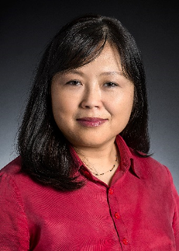Hui Zhang graduated from University of Pennsylvania with a Ph.D. degree andstarted her lab at Johns Hopkins University in 2006. Currently, Dr. Hui Zhangis a professor of Pathology, Oncology, Chemical and BiomolecularEngineering, and Urology at Johns Hopkins University. She is the director ofthe Mass Spectrometry Core Facility and Proteomic Research in the Center
for Biomarker Discovery and Translation. The research in her group focuseson understanding the functions of proteins and protein modifications,especially protein glycosylation in biology and human diseases. Please visit her publications page.

Seminar Coordinator:
Dr. Trevor Del Castillo, Assistant Professor
trevor.delcastillo@njit.edu

