DEPARTMENT OF CHEMISTRY AND ENVIRONMENTAL SCIENCE
SEMINAR SERIES
FALL 2024

WEDNESDAY, NOVEMBER 20th 2024
1:00PM-2:20PM

HYBRID
Tiernan Lecture Hall 1
https://njit-edu.zoom.us/j/91712374995

GUEST SPEAKER
Prof. John C. Lukesh III
Associate Professor and F. M. Kirby Family Faculty Fellow, Department of Chemistry
Wake Forest University (Winston-Salem, NC)

TOPIC
Investigative Tools for Probing the Chemical Biology and Therapeutic Utility of Reactive Sulfur Species

ABSTRACT
Hydrogen sulfide (H₂S) has been historically dismissed as a highly toxic industrial and environmental pollutant. This limited viewpoint began to shift, however, in the mid 1990s when it was suggested that H₂S may play a key role in neurotransmission. Since this initial landmark report, numerous studies have been carried out which further highlight the vast physiological and pathological effects of H₂S within mammalian systems, including its ability to lower blood pressure, reduce inflammation, and promote angiogenesis and wound healing. As such, H₂S is now widely recognized as an important endogenous signaling molecule and, along with nitric oxide (NO) and carbon monoxide (CO), is considered to be the third member of the gasotransmitter family.
To further advance this burgeoning field of research, our group is interested in the design and synthesis of small organic molecules that aide in both the detection and release of this transient gas under biologically relevant conditions. Specifically, our group has successfully developed highly versatile reaction-based fluorescent probes for the selective detection and imaging of H₂S in both water and in living systems, along with small molecule donors that slowly liberate H₂S and other reactive sulfur species (such as hydropersulfides) in response to a specific biological stimulus. Together, these compounds provide a useful set of chemical tools that may be employed in future studies aimed at elucidating the chemical biology and therapeutic potential of hydrogen sulfide and other reactive sulfur species.
BIO
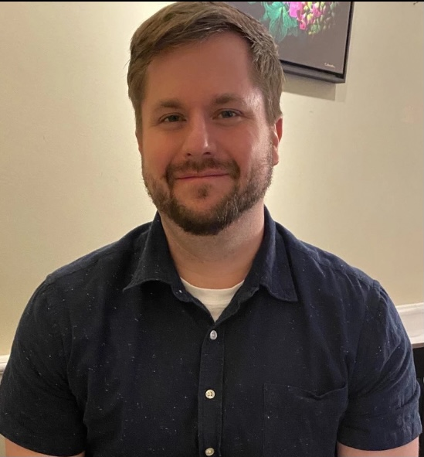
John grew up in Cedarburg, WI. He received his B.S. in chemistry at the University of Wisconsin–Milwaukee, doing undergraduate research with Alan W. Schwabacher. He earned his M.S. and Ph.D. degrees in chemistry at the University of Wisconsin–Madison with Ronald T. Raines and held a postdoctoral appointment at The Scripps Research Institute with Dale L. Boger. Since 2017 he has been a member of the faculty at Wake Forest University in the Department of Chemistry.
Honors and Awards
- NIH NIGMS Maximizing Investigators’ Research Award (MIRA), 2024
- F. M. Kirby Family Faculty Fellowship, 2022–2025
- NSF CAREER Award, 2022

Seminar Coordinators:
Dr. Trevor Del Castillo, Assistant Professor
trevor.delcastillo@njit.edu

